IBM Talent Frameworks
The image below shows all of the job-specific competency and skill information that has been developed and maintained over the last 25 years. This research-based model provides industry-validated data that enables you to quickly unlock cross-functional job requirements for various HR initiatives.
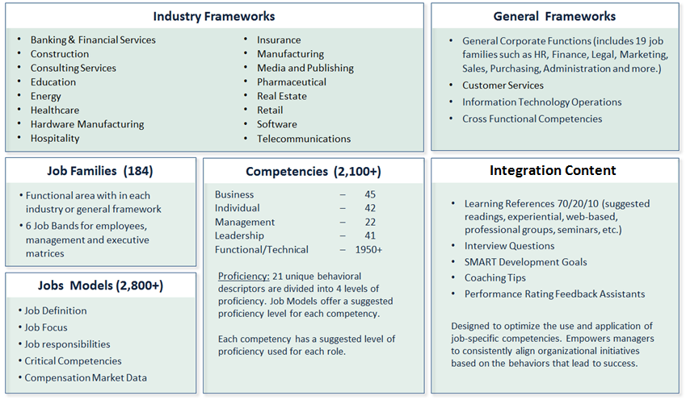

IBM Integration Content
Each Job Profile includes competencies and skills, which in turn each include integration content (e.g. interview questions or learning resources). See the gradient-blue column below for the integration content and how they support your HR initiatives with a rational, common language.
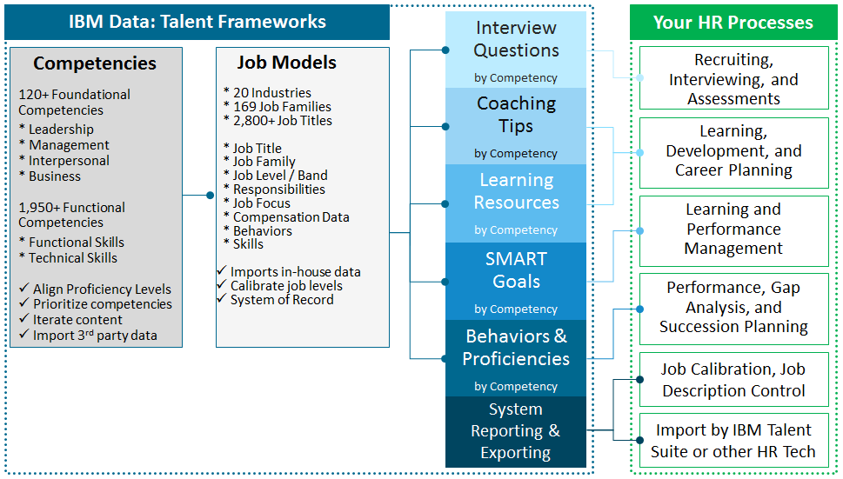
Energy Industry Framework
Following is a summary of the Energy Industry Framework and its job families.
Energy Industry v.2 | EXPLORATION (Oil and Gas) | Discovery of oil and gas deposits through geoscientific data and onshore/offshore exploratory drilling.
9 Job Families | PRODUCTION (Oil and Gas) | Extraction of oil and gas from their original deposits through onshore and offshore drilling.
90 Job Models | REFINING and PROCESSING | Oil refining, petrochemicals, and gas processing.
145 Foundational Competencies | SALES and MARKETING (Oil and Gas) | Wholesale and retail sales and marketing of crude oil, natural gas and petroleum products.
200 Functional Competencies | Fossil and Hydro Power | Jobs related to generation of electricity through fossil fuels or hydroelectric sources.
 | Nuclear Power | Jobs that are specific to the generation of electricity by nuclear power.
 | Energy Business Services | Jobs that are common to all energy industry companies independent of the type of energy source.
 | Power Supply and Distribution | Jobs related to electric power distribution.
 | Retail Energy Services | Jobs related to the marketing and sales of energy products to commercial and residential consumers.

Job Profile Example - Refinery Process Engineer
Following is the job-specific content provided by our solution for the Energy Retail Sales Rep job model. This is how the information displays in CompetencyManager on Cloud, or it is delivered via Excel.
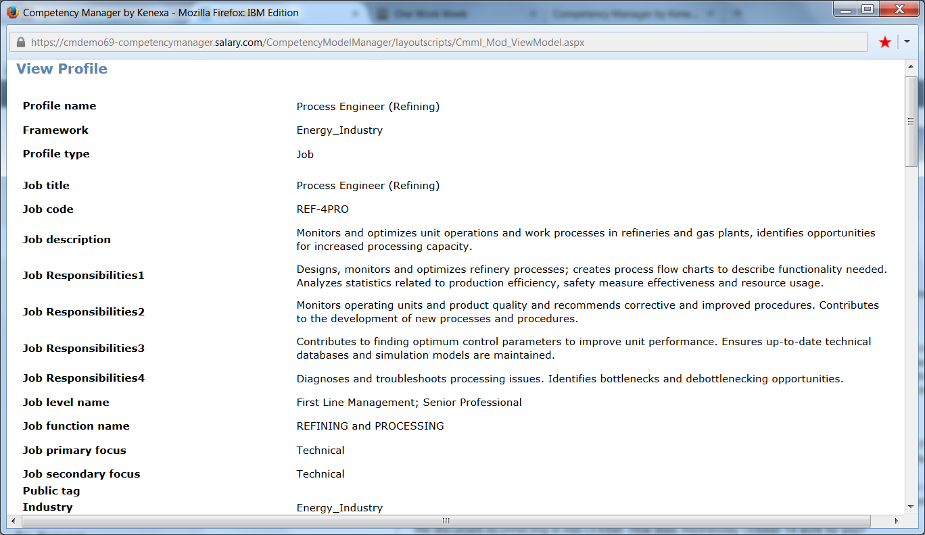
Foundational Competencies – Refinery Process Engineer:
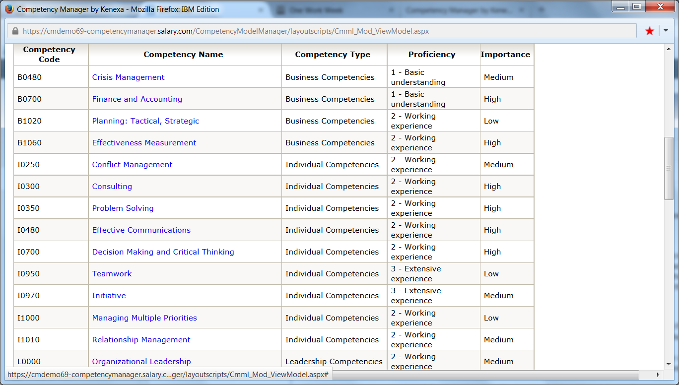

Technical / Functional Skills – Refinery Process Engineer:
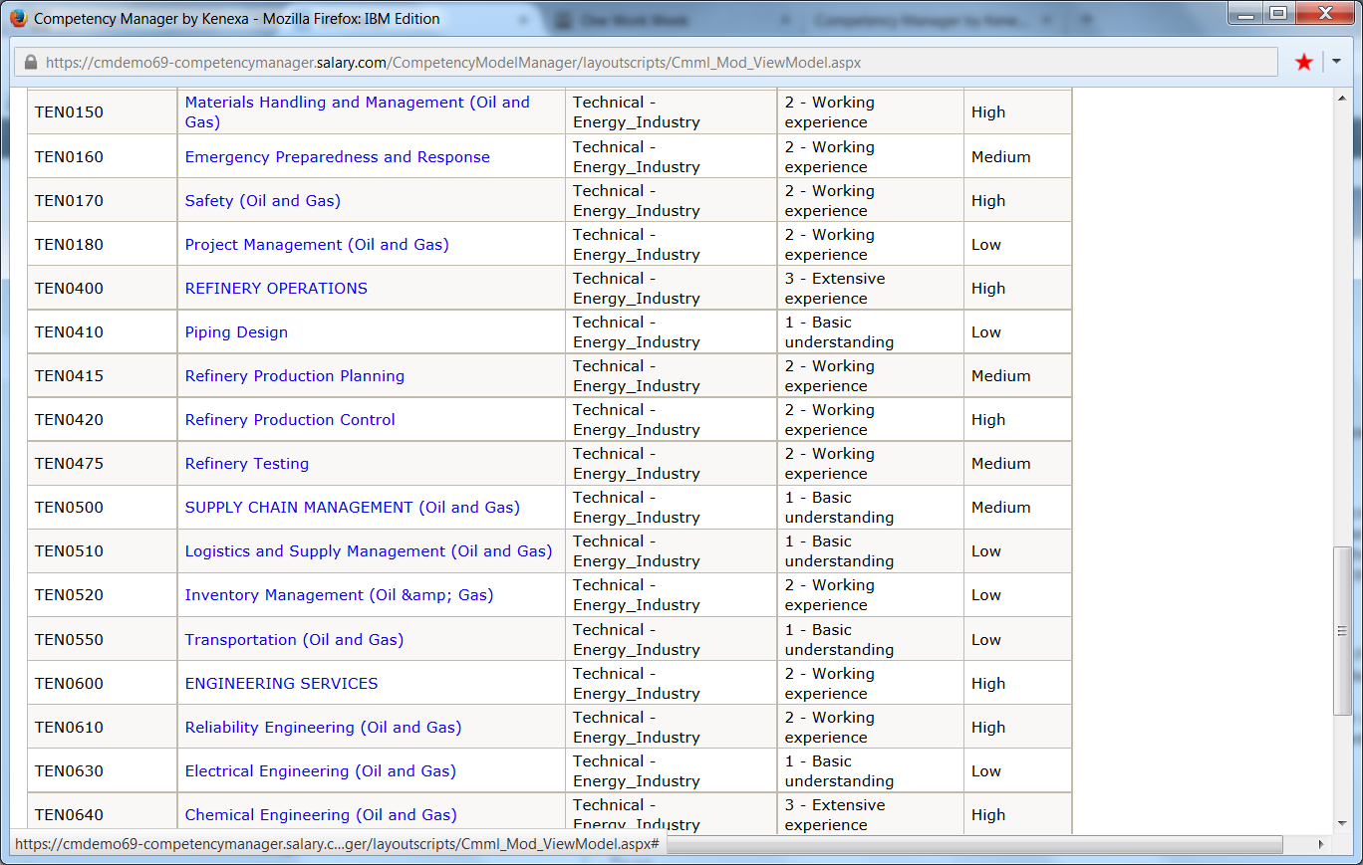
Competency-specific data – “Refinery Testing”:
Note – This data is provided for EACH competency and skill associated to the Refinery Process Engineer role.
DEFINITION – “Refinery Testing”:
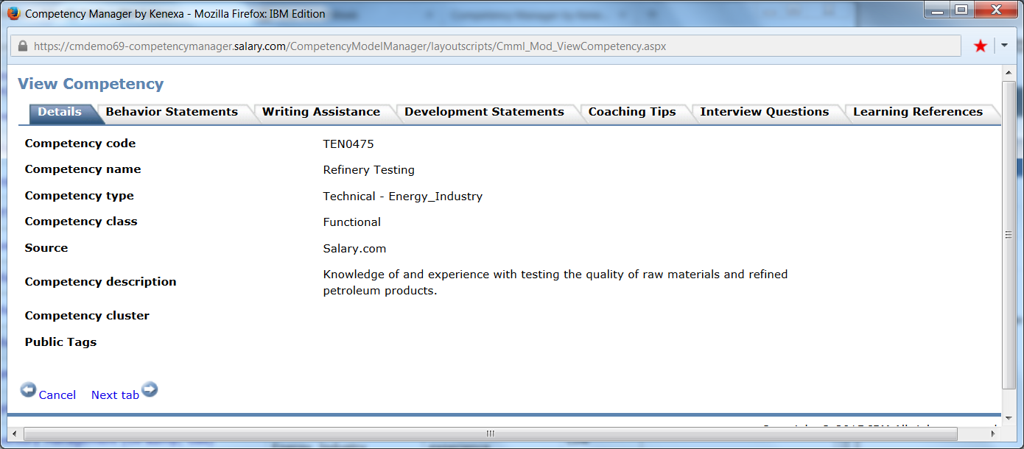

BEHAVIORAL STATEMENTS – “Refinery Testing”:
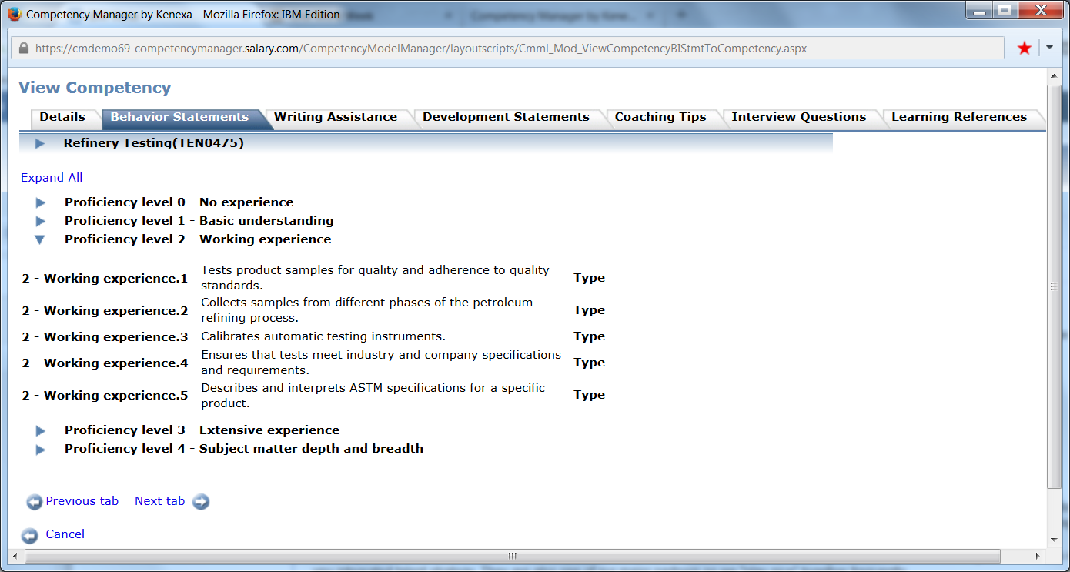

COMPETENCY-BASED INTERVIEW QUESTIONS – “Refinery Testing”:
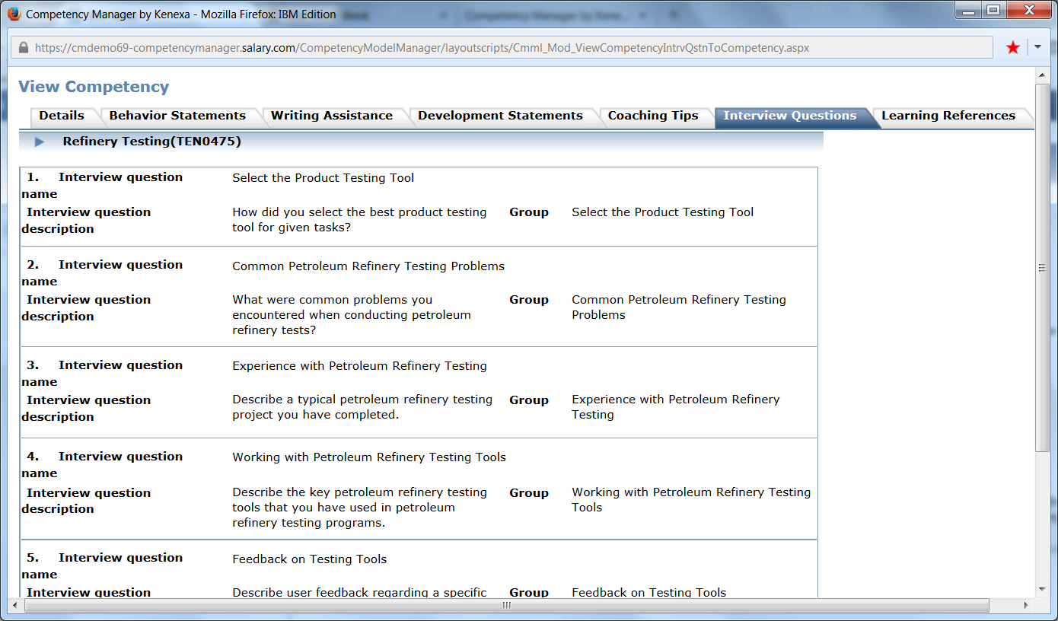

‘SMART’ GOALS / DEVELOPMENT STATEMENTS – “Refinery Testing”:
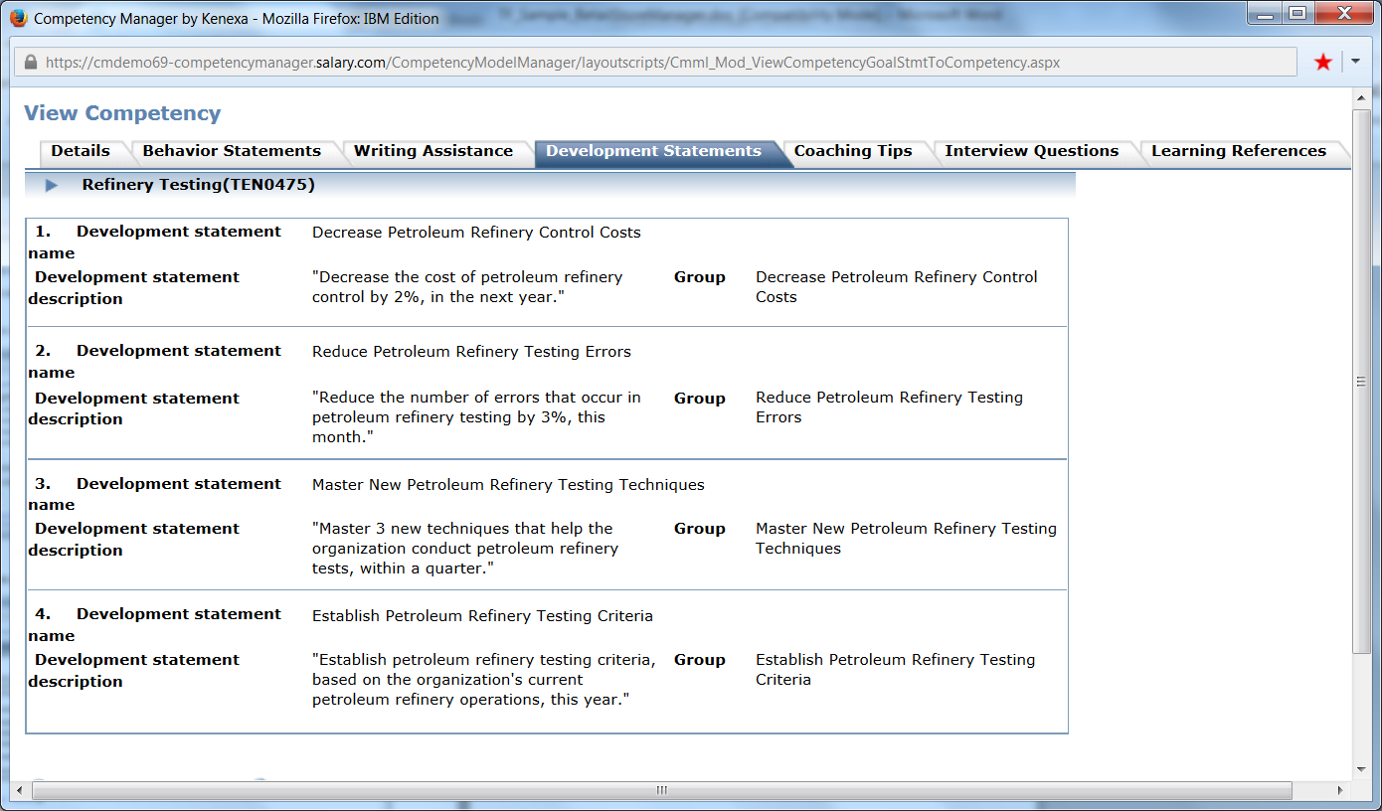

PERFORMANCE FEEDBACK WRITING ASSISTANCE – “Refinery Testing”:
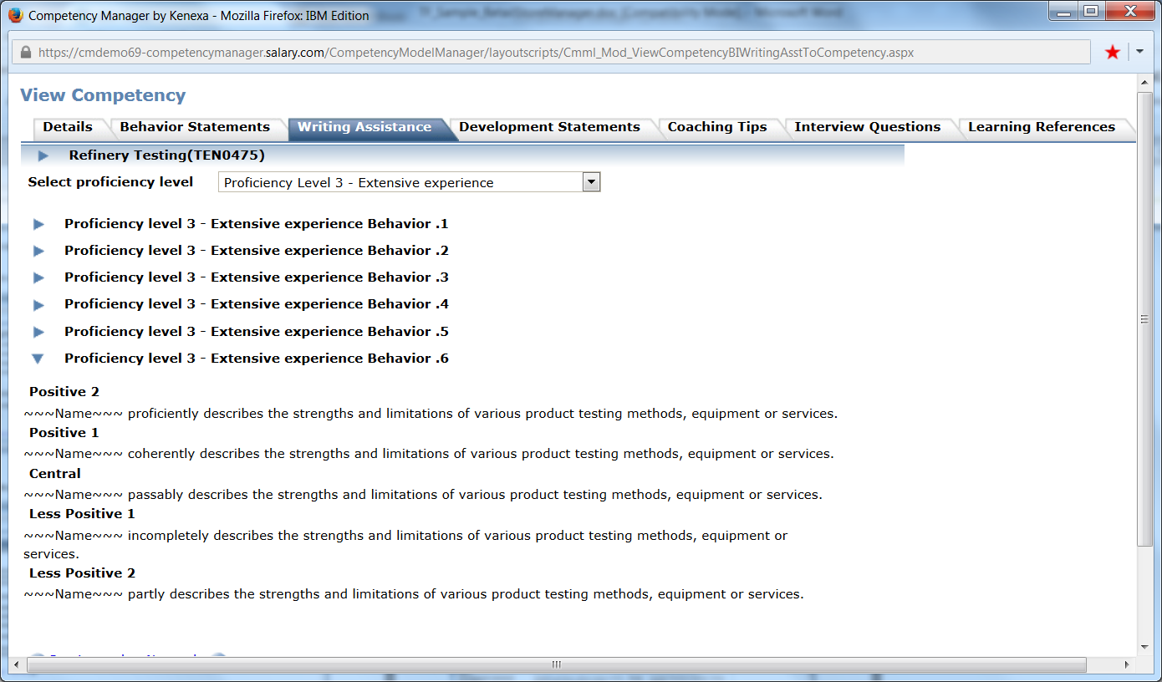
COACHING TIPS – “Refinery Testing”:
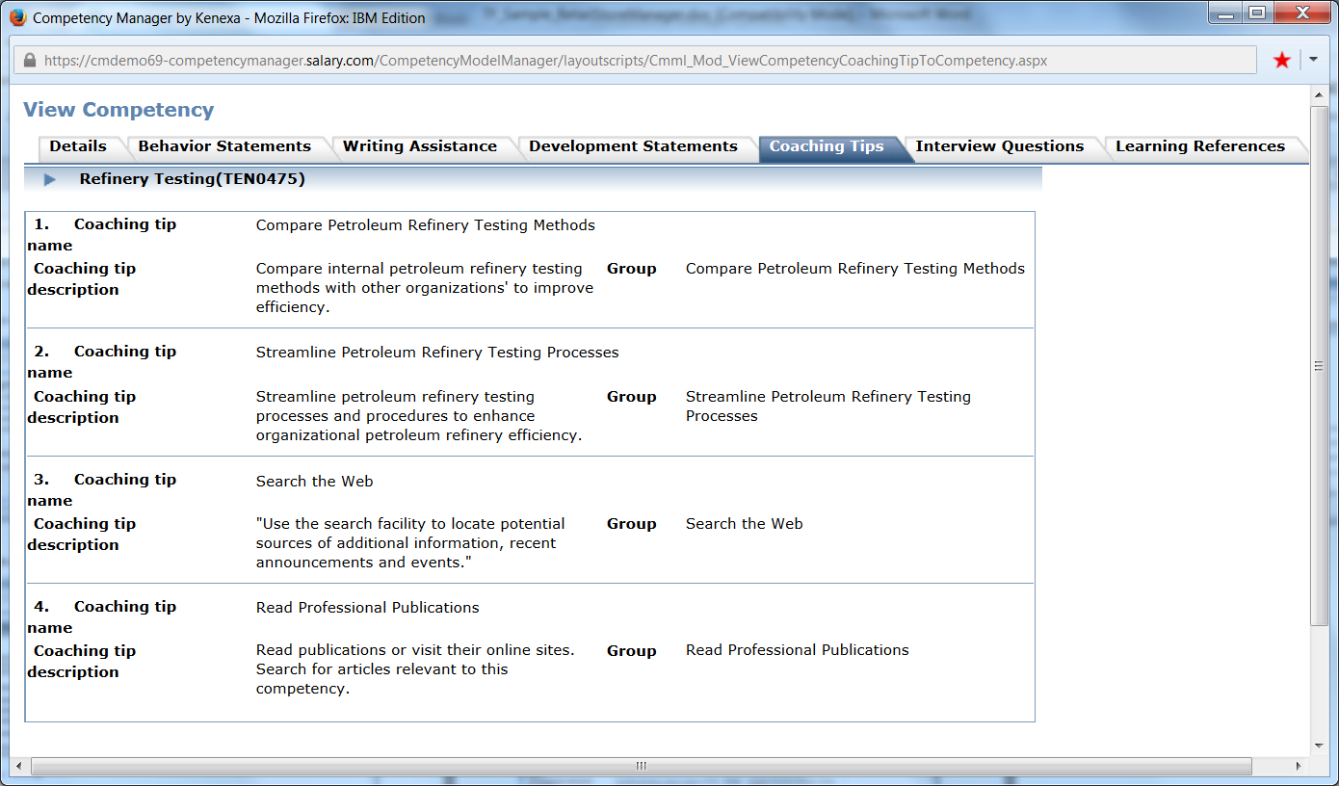

LEARNING REFERENCES – “Refinery Testing”:


